KIRANAM ORGANISATION FOR THE WELFARE OF DISABLED
TELANGANA STATE: PLOT NO: 212/5, KAMMAGUDA PANCHAYAT (GP), TURKAYAMZAL VILLAGE, ABDULLAPURMET MANADAL,RANGA REDDY DISTRICT.
PIN: 501510 PH NO: 9959172223

33nd ANNUAL REPORT FOR THE YEAR 2024-2025
The Management of the KIRANAM ORGANISATION for the Welfare of Disabled in Kammaguda, Abdullapurmet MANDAL, Ranga Reddy District is very happy to place before you this Annual Report for the year 2024-2025 with great pleasure.
The enactment of the Persons with Disabilities (Equal Opportunities Protection of Rights and Full Participation) Act, 2016 has reinforced the commitment of affirmative action and resolve to empower the Persons with disabilities and mainstream in the Society. According to 2011 Census, there were about 2.68 crore persons with disabilities in India, constituting 2.21% of the total population of India. Since our State Government of Telangana is committed for the upliftment and welfare of the handicapped and downtrodden, we find that there is every need to provide higher education, health, Rehabilitation, Sports and Recreation, non-discrimination and social security of the handicapped for rehabilitation to lead a respectable life in the Society. Our Welfare activities for the benefit of the disabled children need no detailed explanation in the field of Mentally Challenged of various categories like Cerebral Palsy, Multiple Disabilities and Mental Retardation etc,.
You know the contribution we are extending in the field of disability and we always take the lead in reaching all the organizations working in this field with useful information and new initiative to bring our problems and articulate with State and Central Government Agencies. We had firm faith in sharing all the concerned information, and issues to enrich our experiences and build mutual strength. We are trying to improve the quality of life to feel them as integral part of the Society, resulting in social security and self esteem.
The DDRS has been revised with effect from lst April, 2023 and the provisions of the scheme are
- Special School for Intellectual Disability Cerebral, Palsy, Autism Spectrum Disorder , Multiple Disabilities.
- To give special inputs for the improvements of the communication/language/motor/social/adaptive skills of the children with ID/CP/ASD/MD/Db/Muscular Dystrophy etc.
- To create and enabling environment to ensure equal opportunities, equity, social justice and empowerment of persons with disabilities.
- To encourage voluntary action for ensuring effective implementation of the Rights of Persons with Disabilities, Act, 2016.
We have taken up Special School for children with disabilities of all categories previously. Now it has been to MR children, mild, moderate, severe and multiple disabilities to suit the revised scheme.

Our staff members with great faith to look forward by undertaking the survey work in the field of disability. They are covering the nearest villages starting from Turkayamzal to Brahmanas. They identified about 150 children. The parents of these children were convinced to admit their Children in the Special School so that acquire knowledge and improve mentally. They are informed about the welfare measures providing by the State and Central Governments. The present strength of the children is 75 and the strength of the staff is 22 including 6 Special Teachers, and Part Time Experts. Actually we are planning to cover more remote villages in almost all the Mandals of our Ranga Reddy District, which depends up on the various facilities to be provided to the Intellectual Disability Children and funds, required for that purpose. They are striving every nerve to bring behavioral changes and enhancement of their cognitive abilities with reference to the children with intellectual disability and specialized skills that facilitate the process of rehabilitation.
The qualifications and experience in the field of disability has been considered for the recruitment of the Special Teachers in order to give proper training as how to deal with the children and behave with the parents and above all with the visitors and VIPS. Staff meetings were held and they sort out the activities to be performed during the academic year. Important administrative matters were discussed and deliberations were recorded for implementation. Parents meetings were conducted to enlighten them to deal with their wards and take care in their day to day work.
We had a van service to the nearest places to bring children and to leave them to homes giving security with the teachers. Children often come to school with un-awareness, most of the children are unable to cope up with the prescribed norms. The staff members are taking measures to improve their standards. We are undertaking measures for awareness programs. We are taking steps with a multi collaborative approach towards effective implementation of various provisions of the RPwD Act, 2016.
The activities in our Special School are exemplary and were divided under various departments of Psychology, Physiotherapy and Recreational Therapy combined with Yoga Therapy, dancing, play-acting, music, painting, material arts and activities that provide outside world and the individual branch functioned successfully with efficiency to reach the individual
Details of the activities which took place during this Academic Year 2024-25
The Parents Meetings: The frequent meetings with the Parents of the disabled children are taking place as usually, the issues were explained to the parents and many problems are solved by the experienced professionals and the staff. The way of teaching in the Special School gave good results and looking forward to enlarge in due course of time, as there in need to take additional measure to enrich the dignity of individuals with proper medication of health and nutrition for the growth of children. It is proposed to take new handicapped persons in the locality. The staff is able to create new methods of learning and teaching. Parents were given awareness program in an organized manner to extend rehabilitation.

Major Achievements:
We are delighted to inform that KIRANAM Org. was appointed as the State Nodal Agency Centre (SNAC), Telangana State
KIRANAM ORG. was also appointed as the State Level Coordination committee (SLCC) of National Trust.
We have conducted Awareness Camps in our Special School premises with team of eye specialists on the occasion of world Braille Day. Helping the visually impaired not only to provide normal education but also to acquire the skills they need in the present days of technical.
Social functions / National Festivals: We conducted almost all social functions and national festivals inviting well wishers and social leaders to perform them with utmost happiness:
We have conducted educational and entertainment programs for the disabled children during their visits to various places in Hyderabad. The students of our Special School and the trainees in the Vocational Training Centre participated in the Sports Meet conducted in our District. We also conducted one sports competition consisting of four events to both our rural and urban children on World Disabled Day. The celebrations attracted all the parents and children. They were given worthy prizes to all students. The staff members have participated in State Organized Programs. Our Organization was instrumental in organizing workshops.
A team of Doctors and the staff organized the Medical Camps during the month of August and gave therapeutic intervention to the children and gave orientation to parents at nearest villages. It was formed that regular medical check-up of the disabled children will be the priority, else it may lead to serious health issues. Therefore it was mandatory for regular medical check-up that has to be organized by the Government of Telangana. We are taking our children who needed medical checkup and are given personal care. During the medical camps, distinct suggestions were given to the pregnant women relating to Nutrition, Genetic counseling and Precautions to be taken during pregnancy and to plan for a healthy delivery. Our staff and students attended the medial camps organized by State Government and other Institutions. The Health camp conducted by DRDA Staff our students participated for the purpose of aids and appliances for all the disabled persons. Some more NGOs staff also involved in the Camp. It is suggested to conduct such medical camp for students and parents once in every month. Our Kiranam School children went to Area Hospital Vanasthalipuram for general checkup as required..
DDRC RANGAREDDY The DDRC started in the year 2021 to facilitate comprehensive services to persons with disabilities under one roof to provide all essential services to children with disabilities, their parents, caregiver training programs to parents and siblings of CWDs. As per the guidelines issued by the Joint Secretary to Govt. of India, Department of Empowerment of Persons with Disability, New Delhi the DDRC, Ranga Reddy has upgraded as Model DDRC in the revised guidelines w.e.f 01-04-2022. This Centre’s is providing services to nearly 3875 of persons with disabilities in the year 2024-25 in the speech therapy service, Physiotherapy and Psychology services etc.

- Hearing Aids trial
- Speech therapy services
- Psychologist service
- Physiotherapist service
Nirmaya Health Cards have been distributed to all the students. The students have been given training to keep their home in a hygiene and healthy environment.
The Local Level Committee formed by the National Trust is meeting periodically and issued Legal Guardian Ship Certificates to the eligible disabled children. The Guardians expressed their happiness in this regard. It is proposed to extend our services to other institutions in our locality and to the nearest villages in Ranga Reddy District, the other institutions have been alerted about the program.
A team of Doctors and the staff organized the Medical Camps at nearest villages. It was formed that regular medical check-up of the disabled children will be the priority, else it may lead to serious health issues. Therefore it was mandatory for regular medical check-up that has to be organized by the Government of Telangana. We are taking our children who needed medical checkup and are given personal care. During the medical camps, distinct suggestions were given to the pregnant women relating to Nutrition, Genetic counseling and Precautions to be taken during pregnancy and to plan for a healthy delivery. A Medical camp was conducted by the Government Hospital, Vanasthalipuram. All the students, parents, teachers, staff attended the program. The Doctors checked up the children and issued ‘new certificates’ for proper implementation of pension for Disabled persons.
The State Government of Telangana have recognized the School while giving Code Number 7199/B3/2016 to start a School for public. We started SRS School for regular students for the classes Pre-Primary to VII Classes. We are trying to improve its conditions by admitting the children in the nearest villages.
I am happy to take this opportunity to appeal all the philanthropic persons and other institutions to contribute their mite, generously for the cause of the Disability in our State. Similarly we decided to extend our voluntary services to the other Institutions who need support.
Social functions / National Festivals: We conducted following social functions and national festivals inviting well wishers and social leaders to perform them with utmost happiness:
Independence Day

On the Occasion of The “76nd Independence Day” All the students have come in Tri-colour dress code to the School for the Flag hoisting Ceremony on 15.08.2024 RDO – Ibrahimpatnam has hoisted the flag and addressed the students, staff, parents and the committee members.

Gandhi Jayanthi

Father of the Nation “Shri. Gandhi’s” celebrations were held in the school on .02-10-2025 Local leaders of Kammaguda has presided the gathering of the students, parents, staff & committee members.

Children’s Day

Competitions were conducted on this occasion and prizes were distributed to the winners by Principal – Kiranam Organization.

Disabled Day

We have to conducted also World disabled day regularly in every year which is fell in the month of December by distribution of Aids and appliances to the persons with Disability.
Republic Day

Flag Hoisting ceremony was organized and Inspector of Police, Vanasthalipuram was invited for the ceremony. Post flag hoisting ceremony refreshments were distributed to the students and prizes were given to the best student of the year.

Telangana Formation Day.

Movie on Telangana Formation was screened and viewed by the students

Haritha haram

Around 100 plants were planted in the campus by the students.

Swatch Bharath

Cleaning activity of the areas in and the campus was done in the presence of Principal.

OUR FUTURE PLANS:
Our future plans include
- To submit proposal for starting Half way home for the Rehabilitation of Treated and Controlled Mentally Ill persons. The Home will be initially setup for around 25 inmates to stay in the hostel. The proposals will be submitted as sought by Telangana
Parents and Children with Disability along with staff of Kiranam Special School

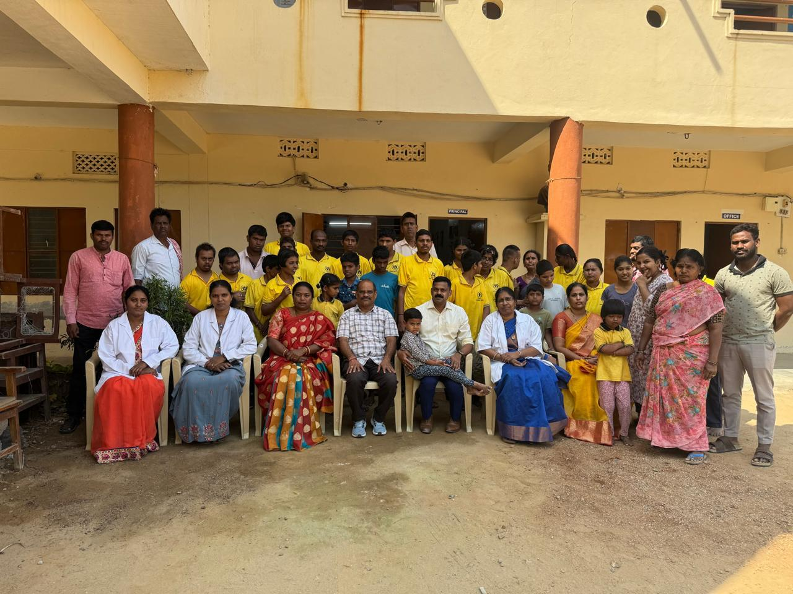
Vocational Training for PwD’s Children’s at Kiranam Special School
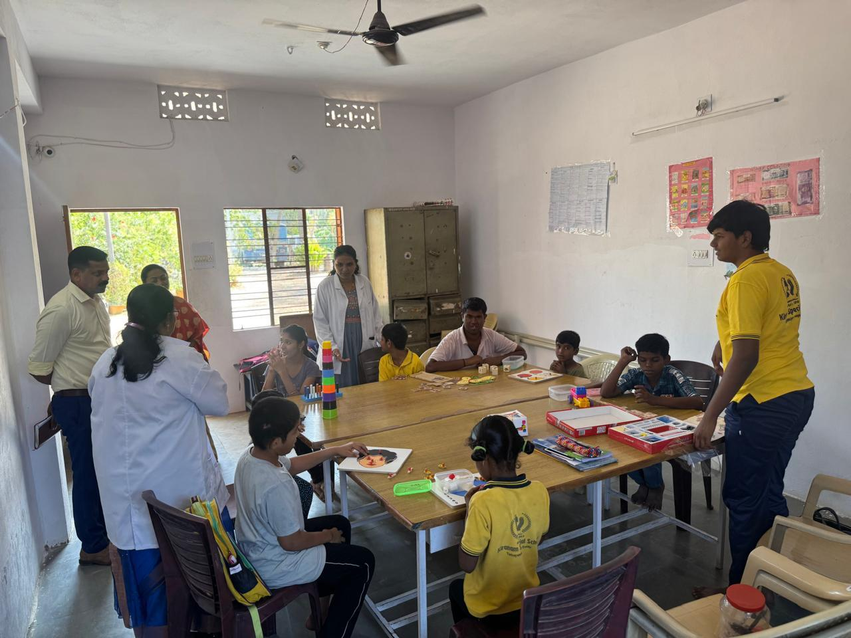

Vocational Training for PwD’s Children’s at Kiranam Special School
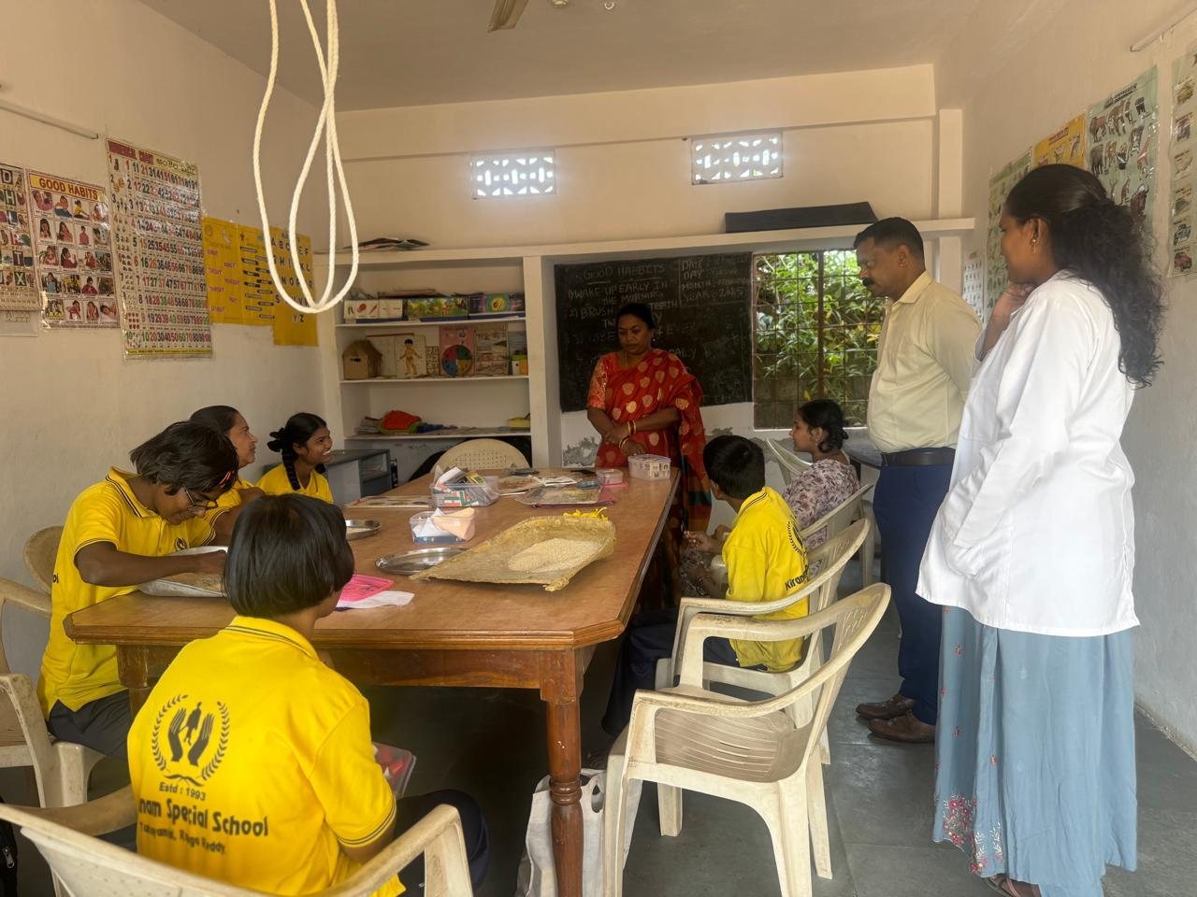
Flag Hosting by the PwD’s Students at Kiranam Special School on the eve of Independence day
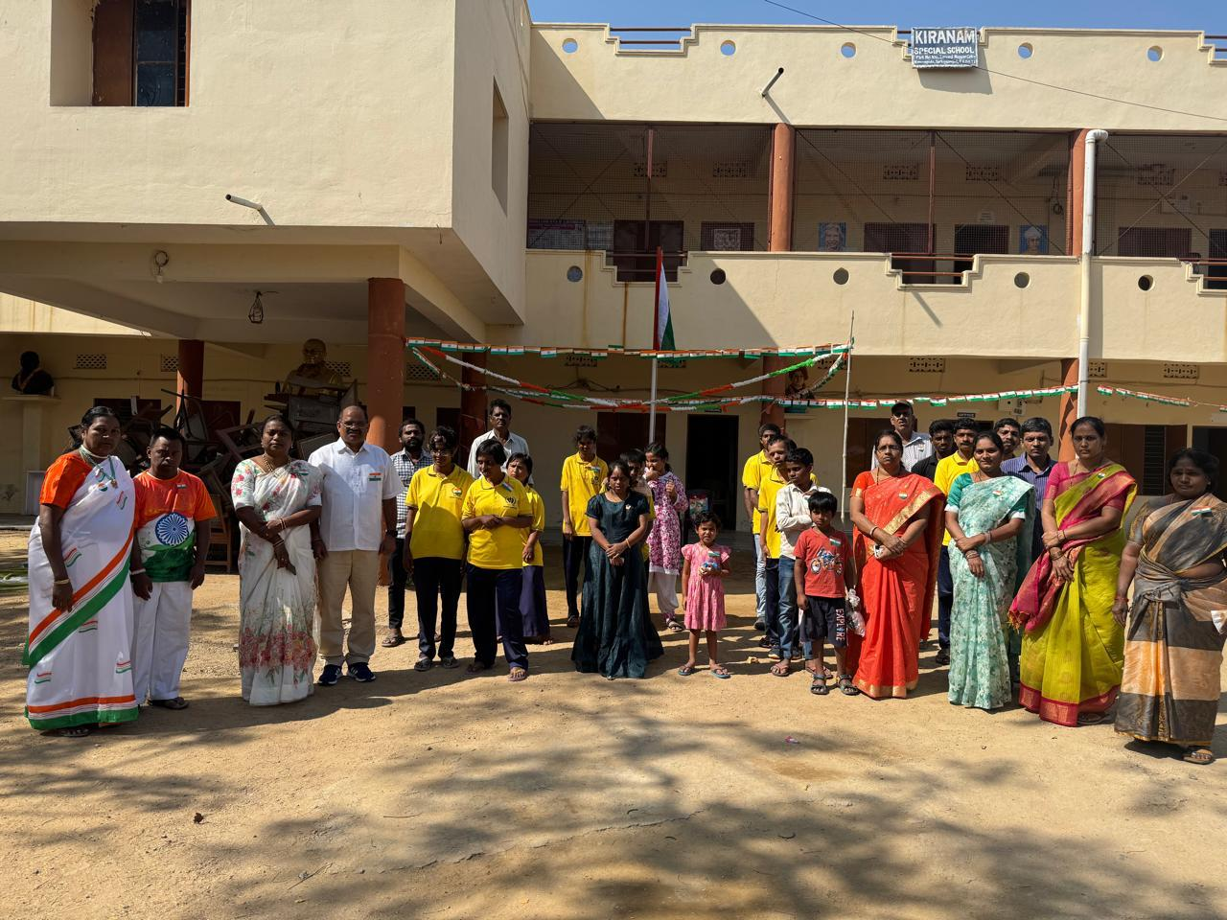

Navadarshan Programme conducted for PwD’s Children’s by CHAI at Kiranam Special School
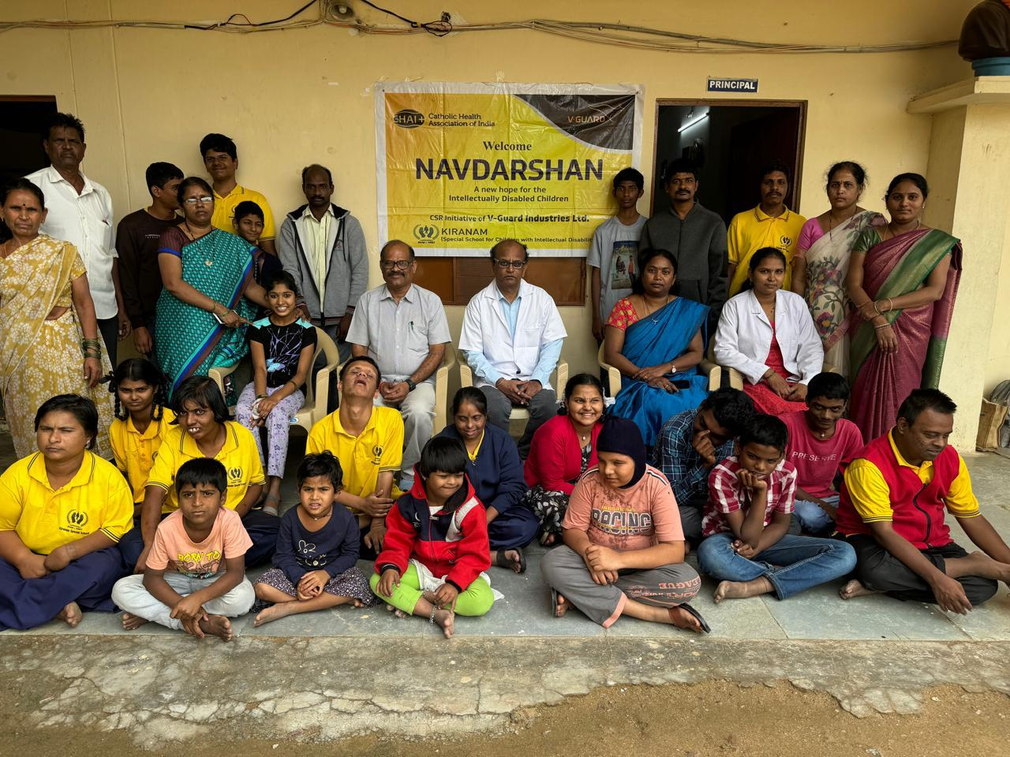
Conducted Medical Camp for Students for PwD’s at Kiranam Special School
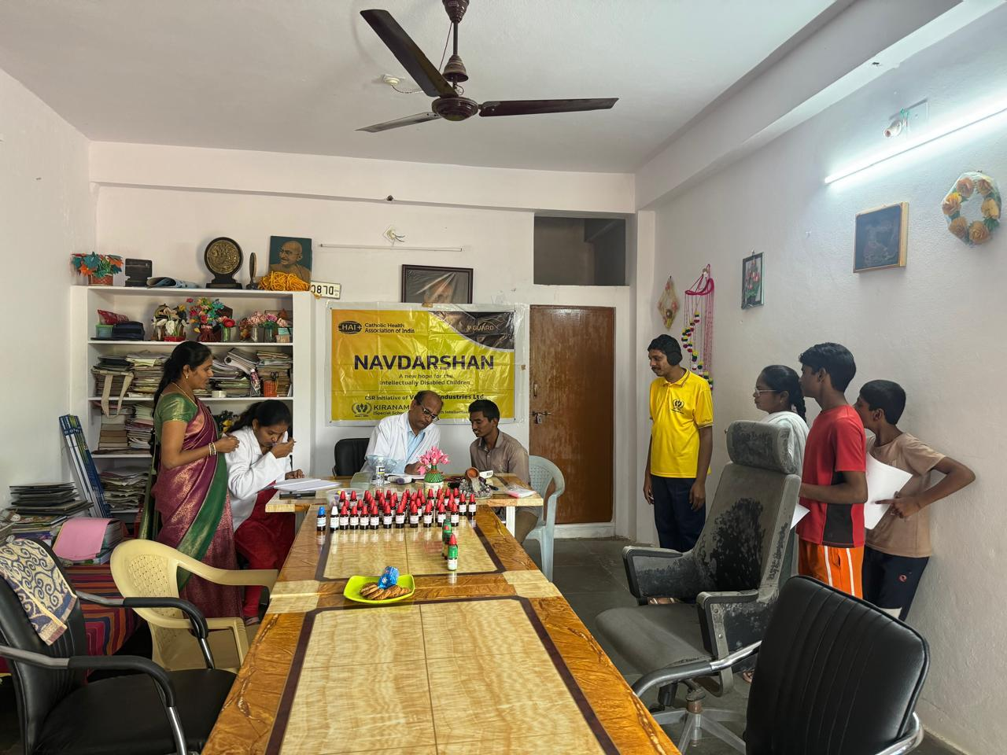

Parents meeting along with Children’s with Disability(PwD’s students) at Kiranam Special Schol
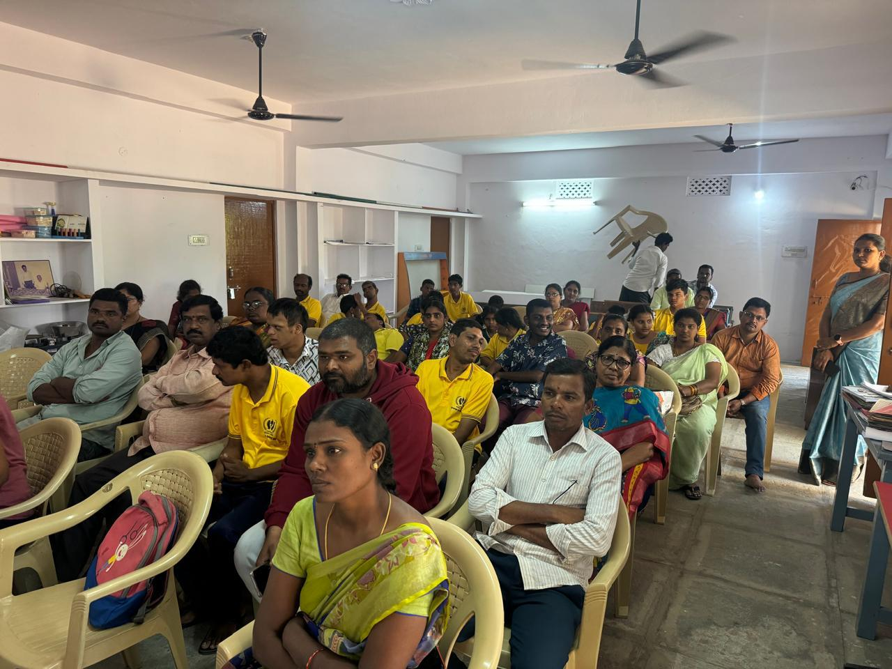
Awareness generation Programme conducted by the CHAI authorities for Parents and Children’s with Disability at Kiranam Special School
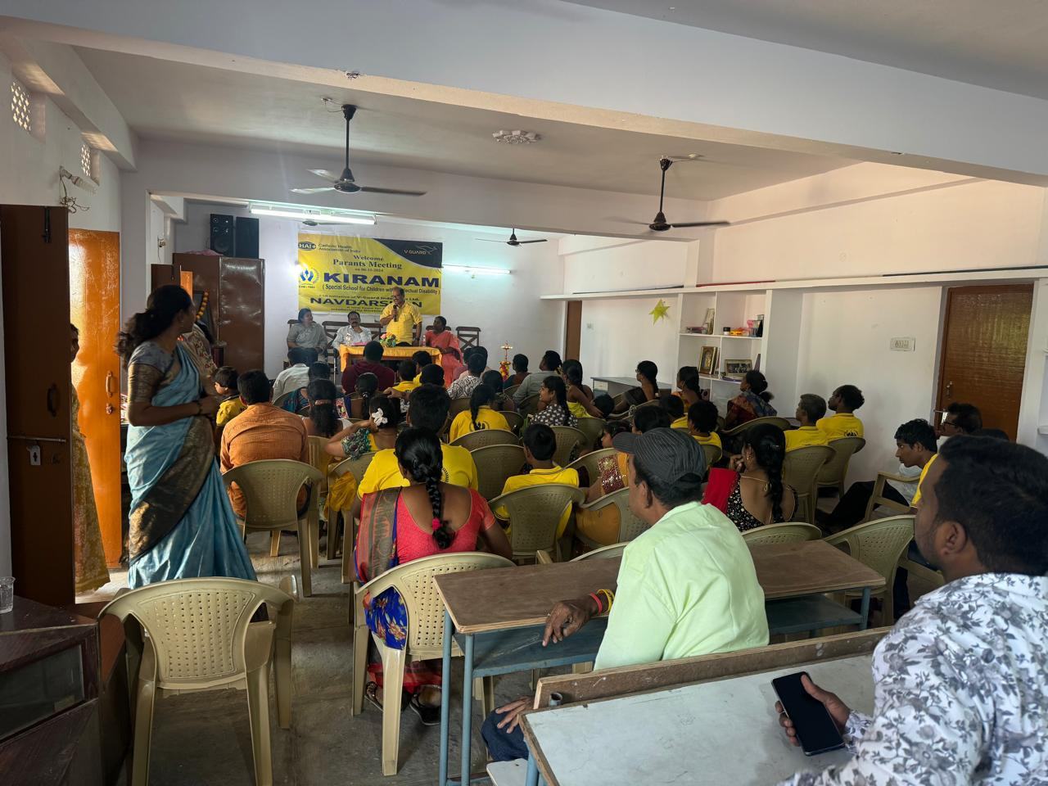

During the Visit of District Welfare Officer, Women Children and Disabled Welfare Dept, Ranga Reddy at Kiranam Special School
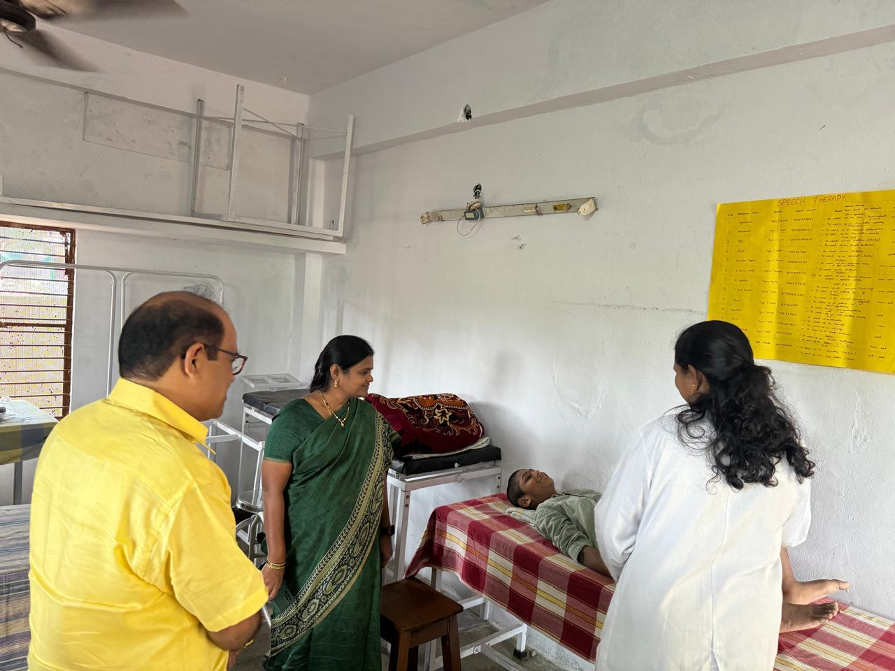

Awareness generation programme for Aganwadi teachers and Bhavitha school along with Parents of the Childrens with Disability conducated by the Kiranam Special School staff
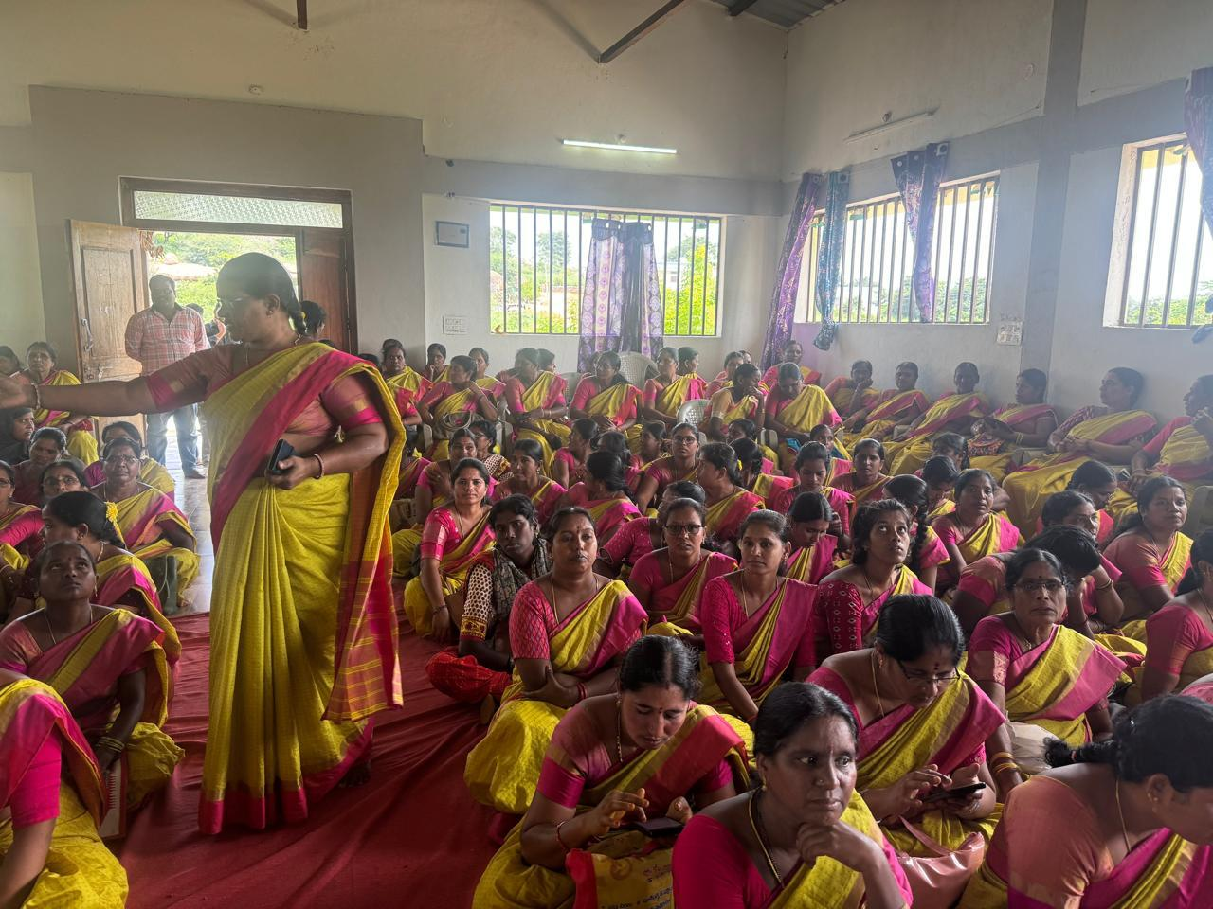

Vocational Training for PwD’s(Beneficiaries) at Kiranam Special School for ID
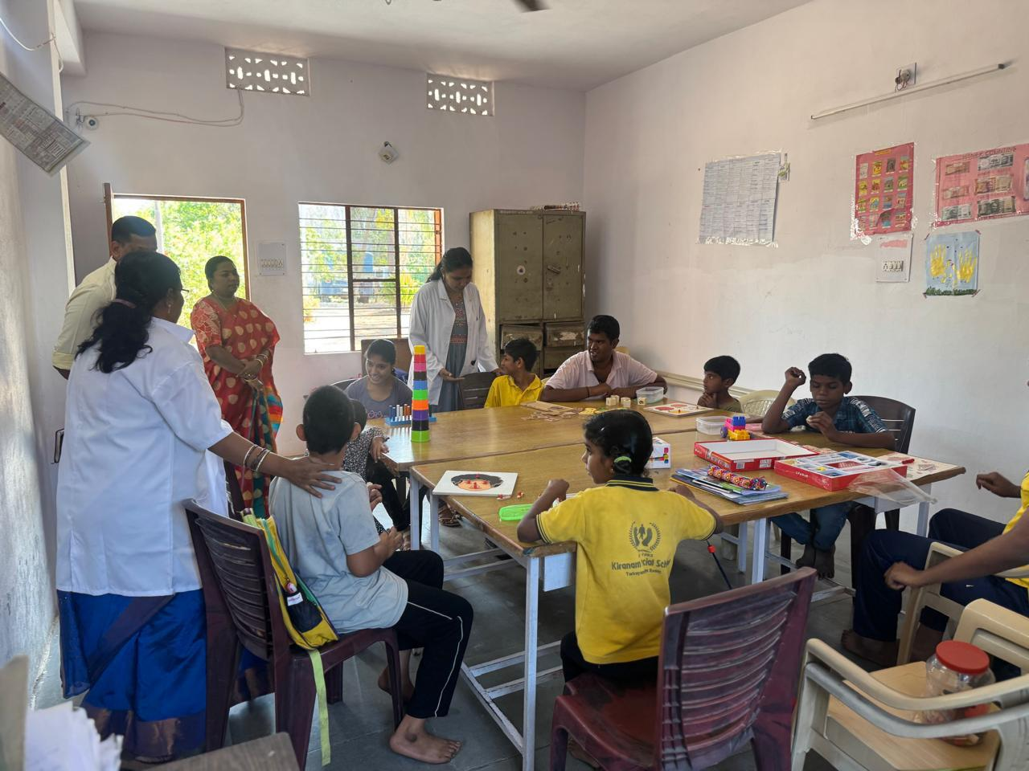

Parents meeting along with Students for PwD’s at Kiranam Special School for ID
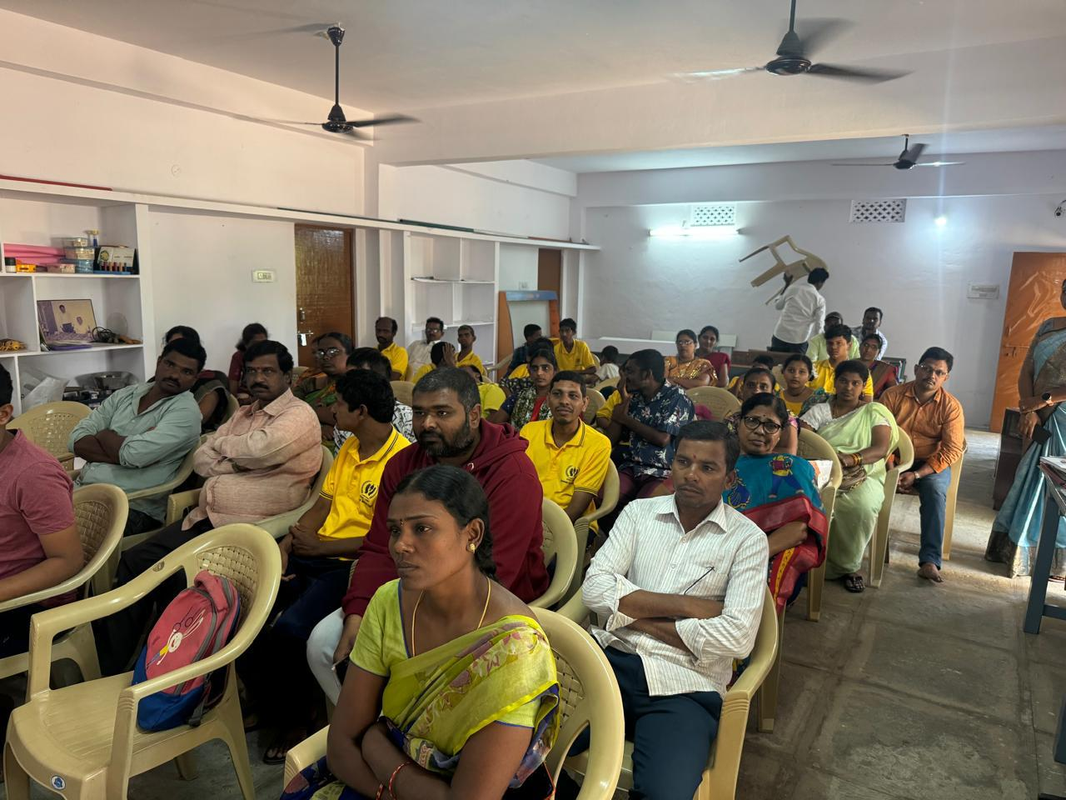

During the visit of District Welfare Officer, WCD&SC Department Ranga Reddy Dist at Kiranam Special School for ID
Awareness generation programme for Bhavitha and Anganwadi teachers at Kiranam Special School for ID
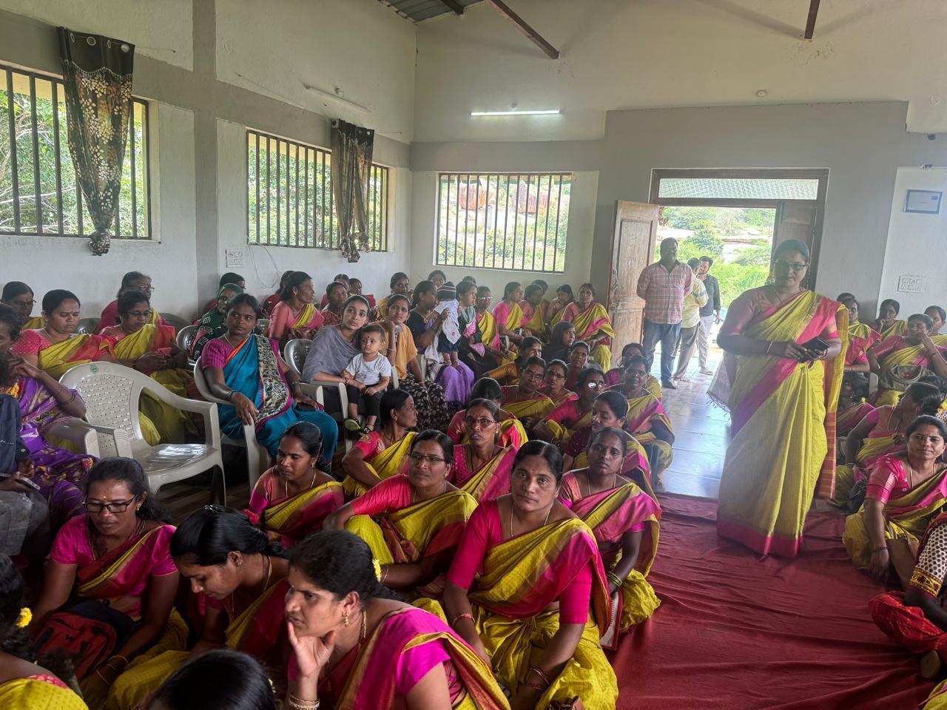

Vocational Training for PwD’s Students(Beneficiaries) at Kiranam Special School for ID
Awareness and training programme conducted by District Legal Services authority and Kiranam Special School for PwD’s students at Kiranam Special School
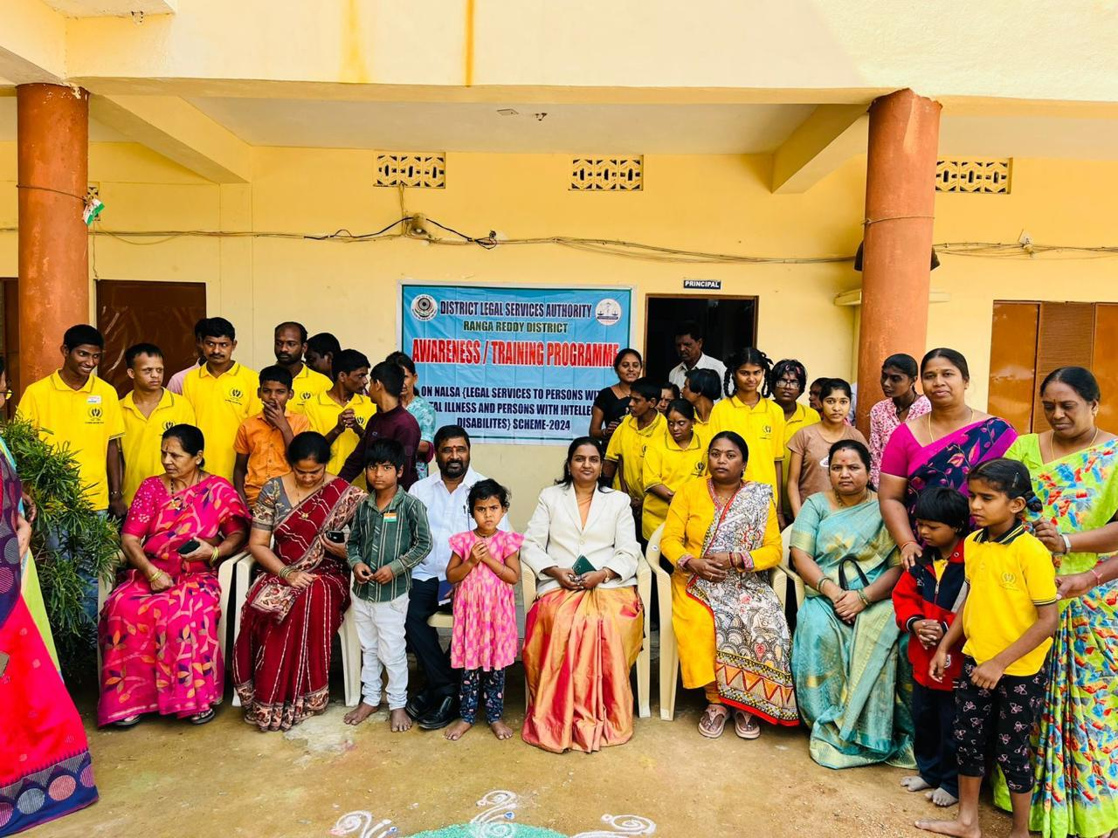

Cultural Programme arranged by the Kiranam Special School for PwD’s students (Beneficiaries)
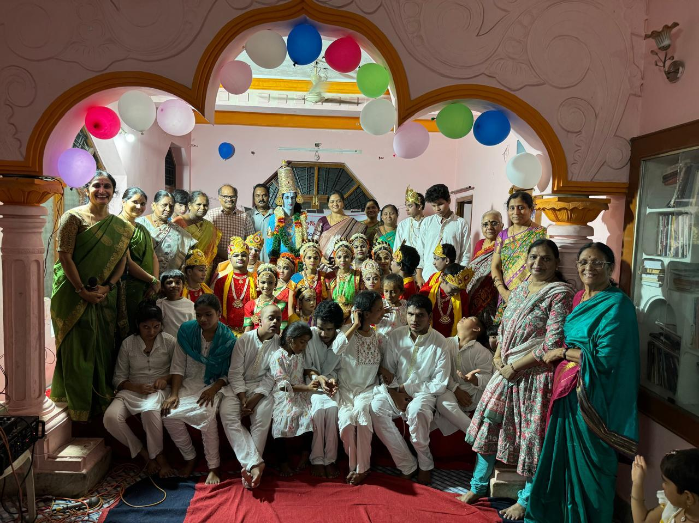
Coaching for PwD’s students at Kiranam Special School for ID
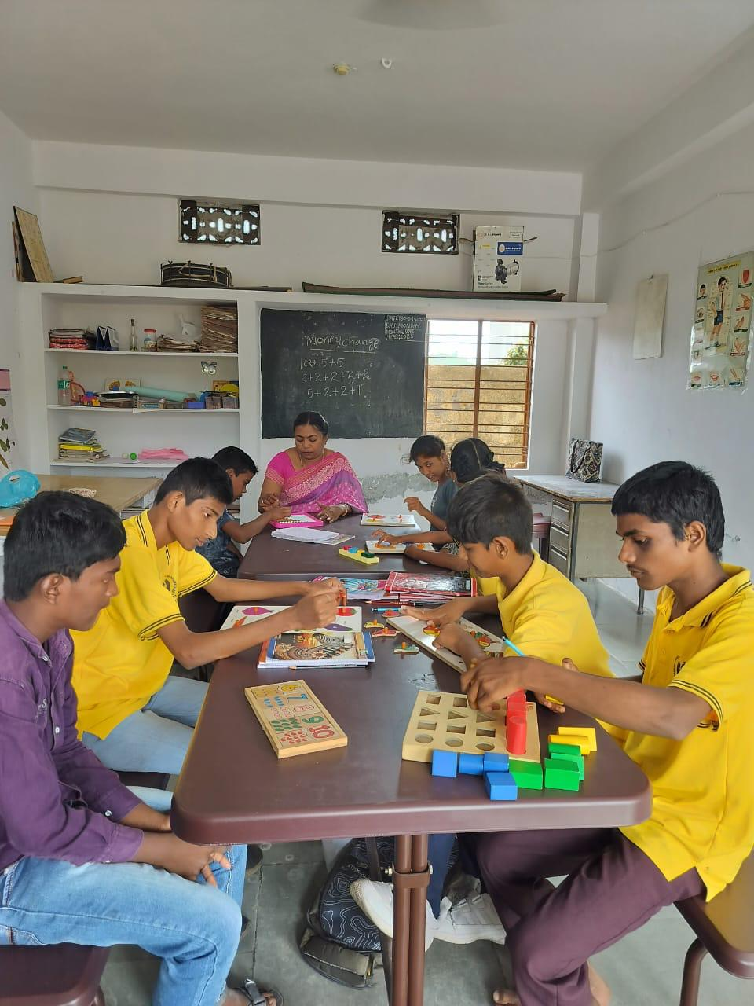

Vocational Training for PwD’s students(Beneficiaries) at Kiranam Special School for ID
